**Organized Program: /src/ & /include/, C++ version**

CMakeLists.txt

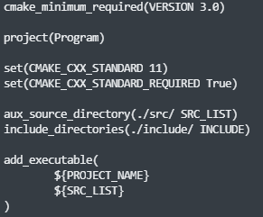

**set:** Once of it’s uses is setting the C++ standard with *CMAKE_CXX_STANDARD* and *CMAKE_CXX_STADARD_REQUIRED.*

**aux_source_directory:** Finding and setting the source files (.cpp) of our project

**include_directory:** Allow our program to use our header files (.h) of our project

**Variable names:** Variable names like ${PROJECT_NAME} and ${SRC_LIST} are Makefile influenced ways of using variable names to make our CMakeLists.txt more readable